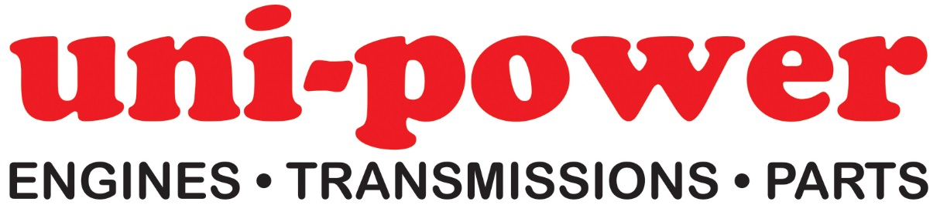

Parts Advisor

Due to ongoing expansion, our Essex based Company has an opening for a Parts Advisor to join the Team in Great Dunmow.

Basic job description: quoting parts via telephone/email & general administration duties

Hours: Monday to Friday 08.00 to 17.00 – 1 hour lunch

We are a Distributor of Industrial Petrol & Diesel Engines, Transmissions & Spare Parts to the Trade & Original Equipment Manufacturers.

The successful candidate will be an extremely self-driven & energetic individual with a proactive & positive attitude, also possessing a meticulous approach to all aspects of the job description.

Ideally, applicants should possess some experience within our industry sector, although full training will be given on our exact range of products; a degree of computer literacy is also essential.

The position offers an attractive salary (Details on request), private medical insurance, company pension scheme & uniform.

If you feel that this position is right for you, please email a full CV (Including at least 2 x references) to tricia@uni-power.co.uk ; or send via post to Uni-power Ltd (Attn: Tricia Paveley), Unit 8 Flitch Industrial Estate, Great Dunmow, Essex CM6 1XJ

Tel: 01371 875331
www.uni-power.co.uk

