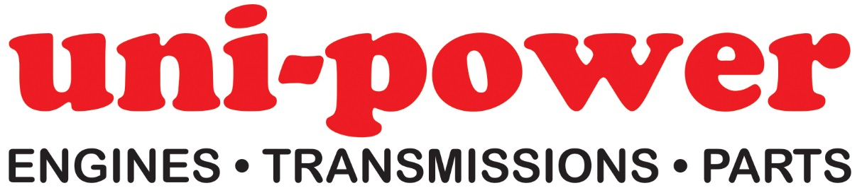

Engine Sales Advisor

Due to ongoing expansion, our Essex based Company has an opening for an Engine Sales Advisor to join the Team in Great Dunmow.

Basic job description: quoting petrol & diesel engines via telephone/email & general administration duties

Hours: Monday to Friday 08.00 to 17.00 – 1 hour lunch

We are a Distributor of Industrial Petrol & Diesel Engines, Transmissions & Spare Parts to the Trade & Original Equipment Manufacturers.

The successful candidate will be an extremely self-driven & energetic individual with a proactive & positive attitude, also possessing a meticulous approach to all aspects of the job description.

Applicants should possess some experience within our industry sector, although full training will be given on our exact range of products; a degree of computer literacy is also essential.

The position offers an attractive salary (Details on request), private medical insurance, company pension scheme & uniform.

If you feel that this position is right for you, please email a full CV (Including at least 2 x references) to tricia@uni-power.co.uk ; or send via post to Uni-power Ltd (Attn: Tricia Paveley), Unit 8 Flitch Industrial Estate, Great Dunmow, Essex CM6 1XJ

Tel: 01371 875331
www.uni-power.co.uk

